March 4, 2021
ANTON ART CENTER ANNOUNCES ANNUAL MACOMB COUNTY SECONDARY STUDENT SHOW

Extra Credit Union presents the Macomb County Annual Secondary Student Show opening on March 6, 2021. This annual exhibition is open to all students in Macomb County currently enrolled in grades 7-12, either homeschooled or in private, parochial, or public schools.

This year, the Anton Art Center received 715 artwork submissions to be juried. Of those, 274 artworks by 191 students presented by 30 teachers from 20 schools were selected for the show! 97 award winning artworks will be on display on site on the first floor of the gallery, and all 274 artworks will be on display in the virtual exhibit on the Anton Art Center’s website (www.theartcenter.org/exhibits).

In lieu of an in-person reception event this year, the Anton Art Center will host a Virtual Awards Announcement on Saturday, March 6th at 2:00pm. The event will be streamed live on the Anton Art Center Facebook page and is open to all. Awards to be made include:
- Best of Grade Ribbon Awards & Art Supply Gift Certificates Award given for three outstanding works (1st, 2nd & 3rd) in each grade. Awards are an art supply gift card for Du-All Art & Drafting Supply, a Mount Clemens local art supply store.
- Honorable Mention Ribbons Awarded to selected artwork in each grade.
- Best Portfolio Ribbon & Cash Award Awarded to one selected senior portfolio.
- Best In Show Ribbon & Cash Award Awarded to one selected exhibited artwork.
- Art Certificates will be awarded to each exhibiting student.
Congratulations, Macomb County students, teachers, and schools!
Phil Gilchrist, Executive Director of the Anton Art Center, is looking forward to the show. “Supporting children in creative endeavors is of the utmost importance to their education and development” says Gilchrist, “Providing this opportunity for students across Macomb County is one of the most significant things the Anton Art Center can do to promote the arts in our community.” The Annual Macomb County Secondary Student Show will be on display in-person and virtually through April 13, 2021.

“The Anton Art Center’s student art shows are exciting community celebrations of the outstanding creativity offered by Macomb County’s schools, teachers, and students. The students’ artwork fills our gallery spaces with a special kind of energy unique to our county’s young people that inspires visitors of all ages”, adds Stephanie Hazzard, Exhibition Manager of the Anton Art Center, “It’s an experience you don’t want to miss!”

For more information about the Anton Art Center, visit www.theartcenter.org or call 586-469-8666. The Anton Art Center is a registered nonprofit organization located in Mount Clemens, Michigan, with a mission to enrich and inspire people of all ages through the arts. The Anton Art Center is open Tuesday through Saturday from 11am until 3pm; admission is free and open to the public. For the best experience, the Anton Art Center encourages calling ahead to schedule a visit, however, walk-ins are welcome.
###

Annual Macomb County Secondary Student Show 2021
Sample images of student artwork on display.

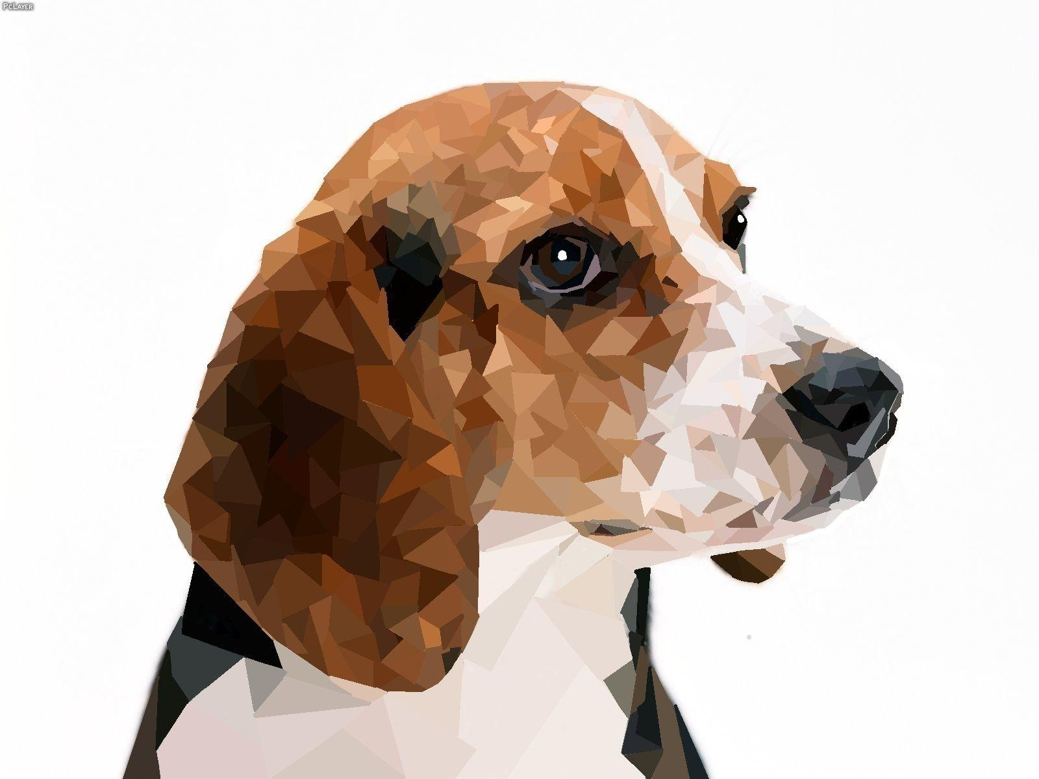  Beagle, Digital Media  Angelina Yalda, Grade 7  Davis Junior High School, Teacher Gail Borowski | 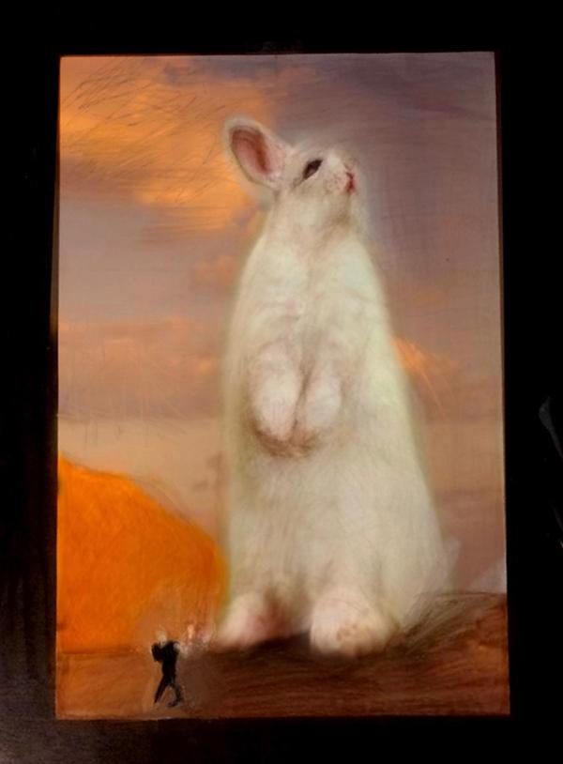  Judgmental Rabbit,  Photography print of original pastel  David Klink, Grade 10  Fraser High School,  Teachers Roger Drabant & Marianne McGinnis
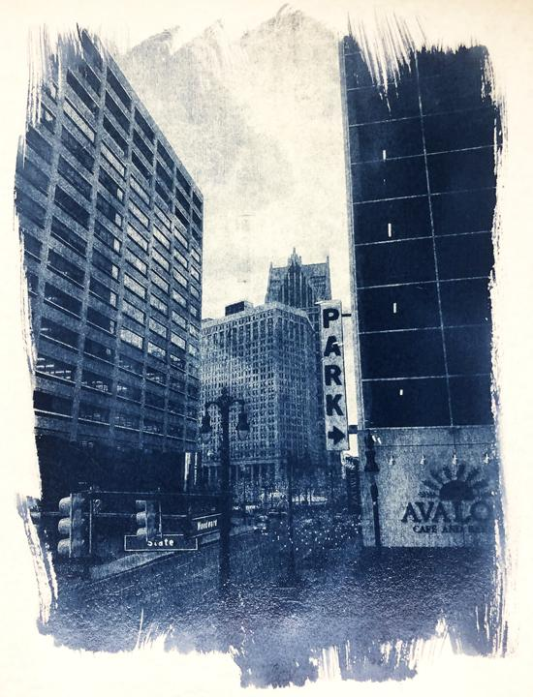  City, Cyanotype photography  Hannah Tassin, Grade 9  Lakeview High School, Teacher Keith Rayner | 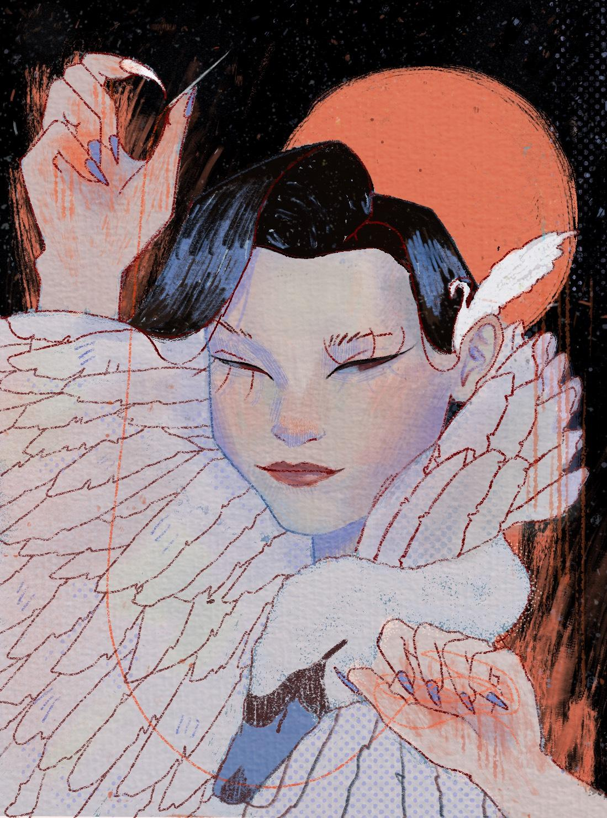  The Swan Maiden, Mixed media  Thy Hoang, Grade 11  Stevenson High School, Teacher Patti Fields
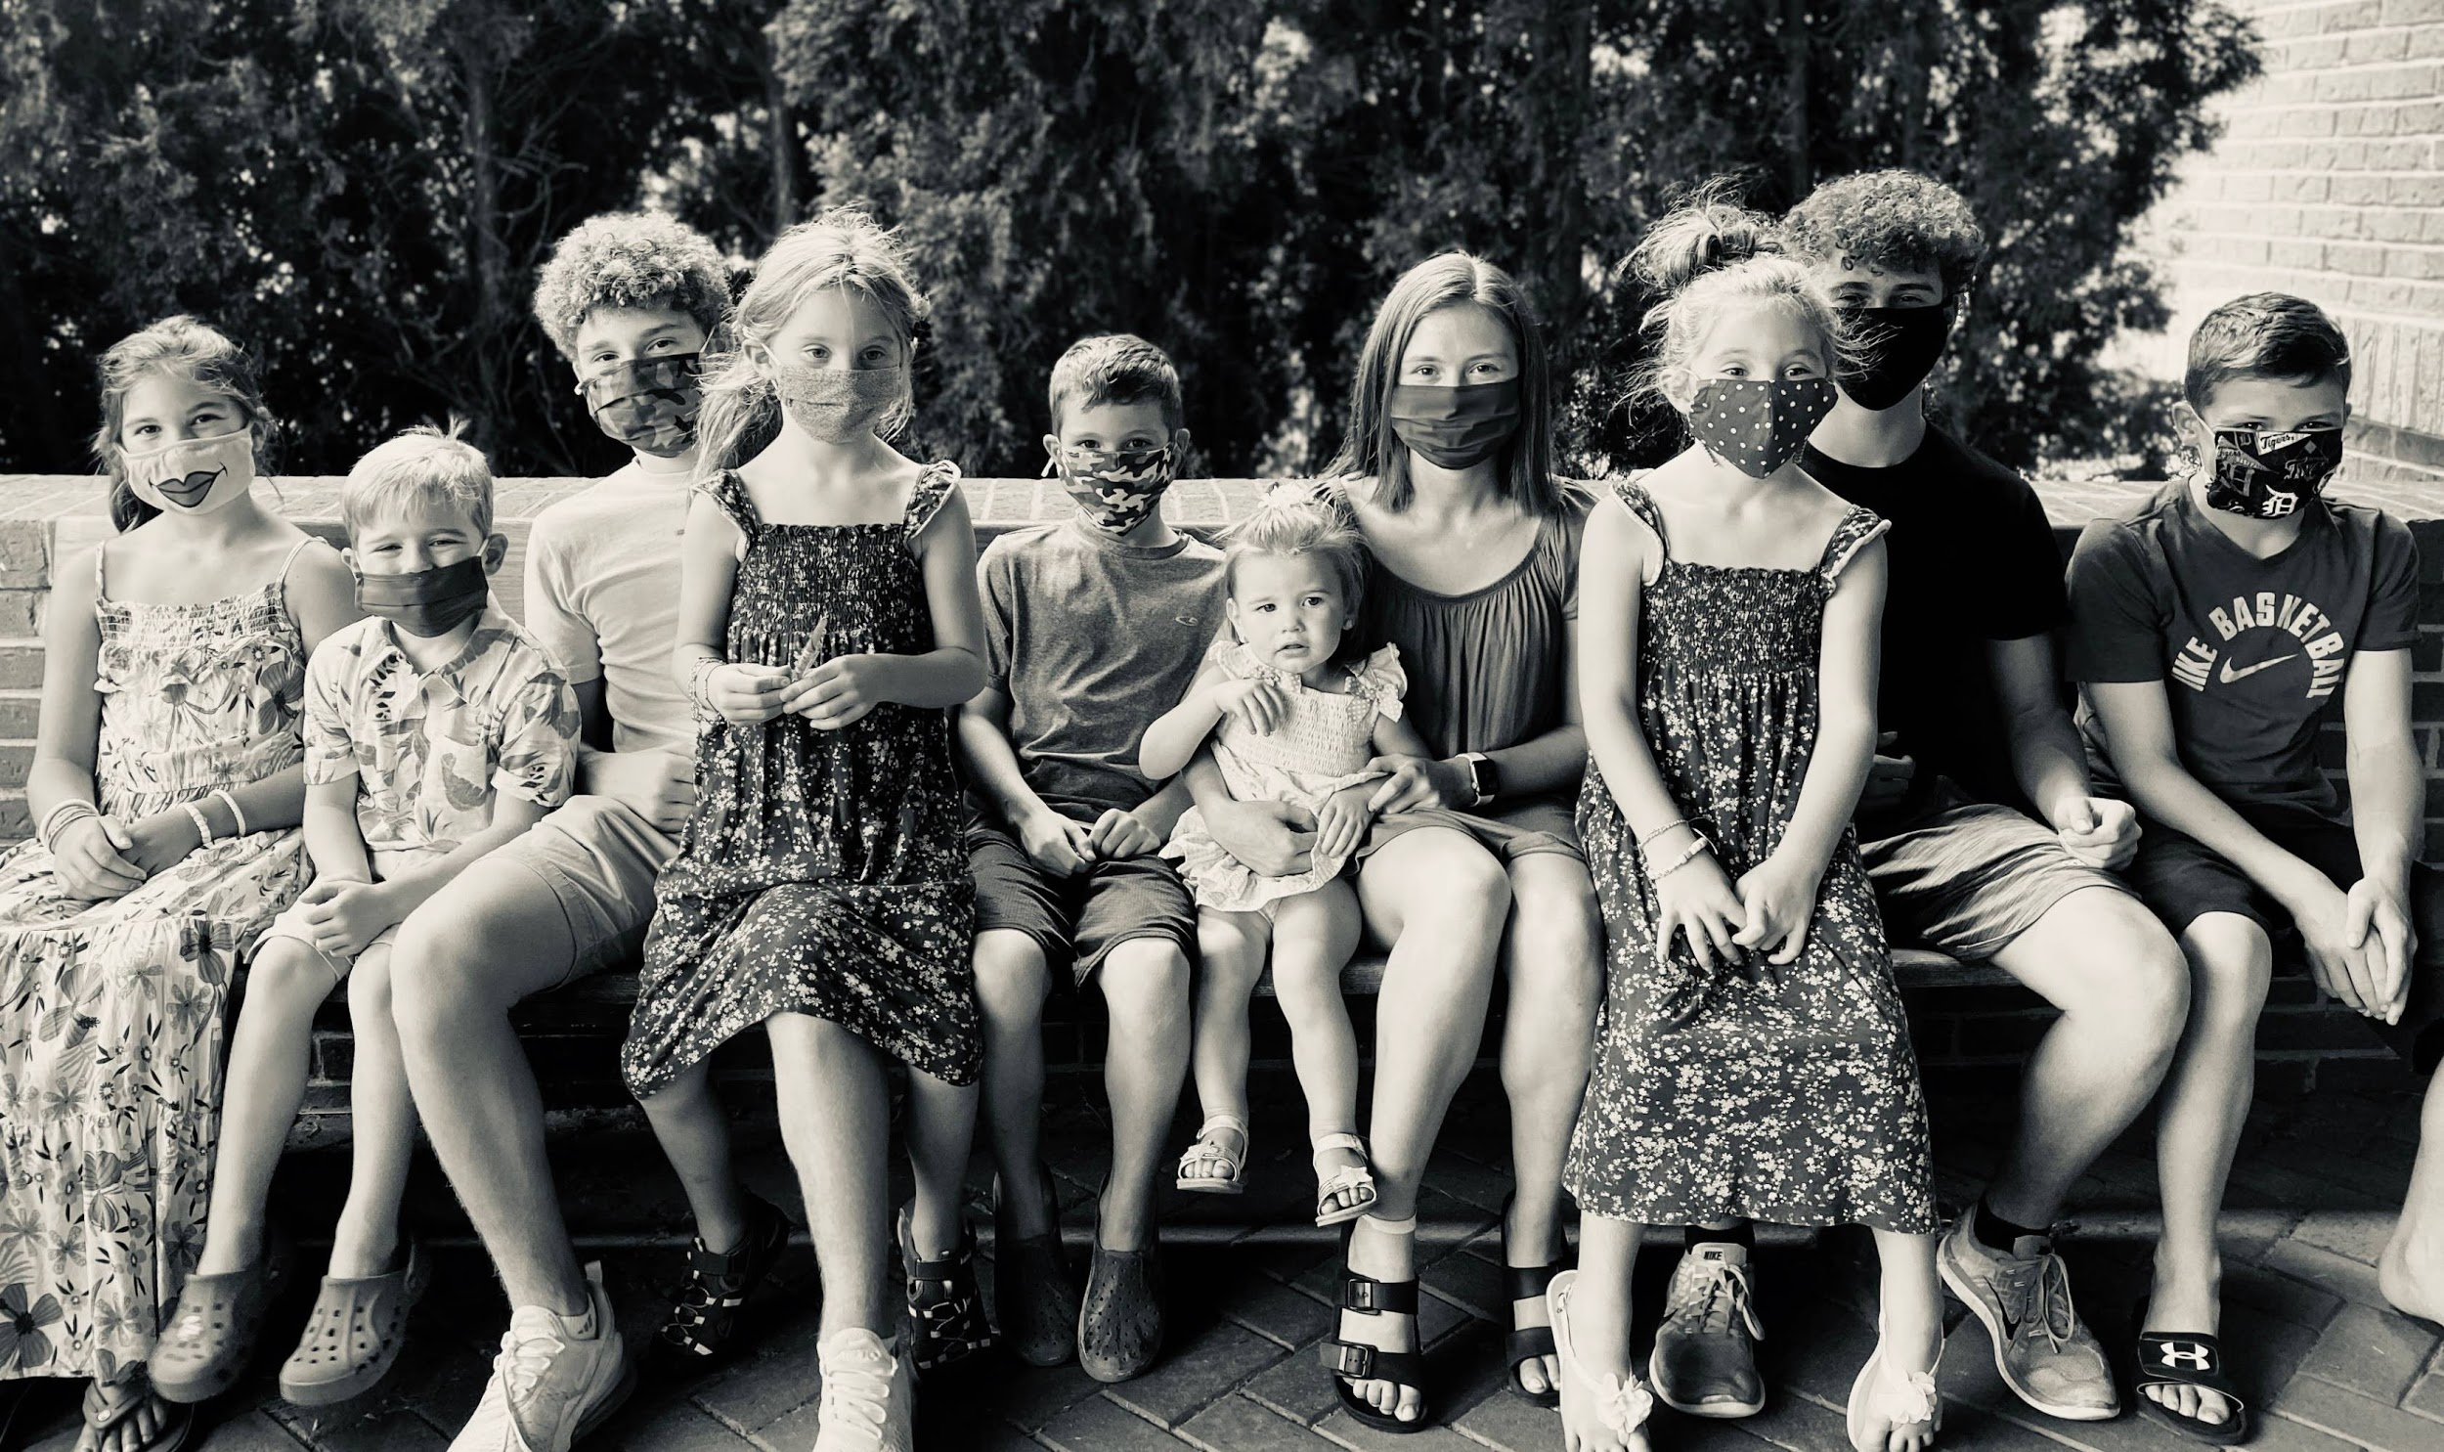  Sosnowski Children, COVID Pandemic Washington, MI, 2020, Photography  Faith Davis, Grade 12  Romeo High School, Teacher Sherri Stough | 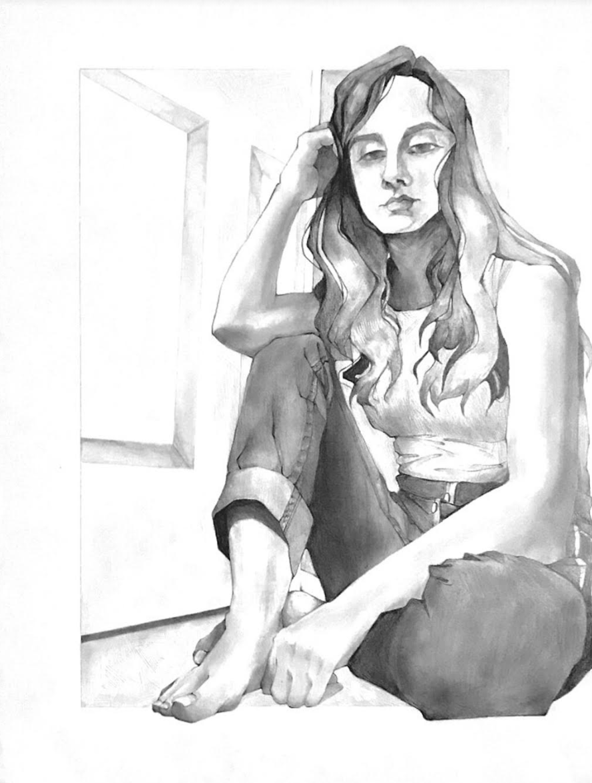  Ponder, Charcoal  Madison Kolioupoulos, Senior Portfolio  Henry Ford II High School, Teacher Marc Palombo
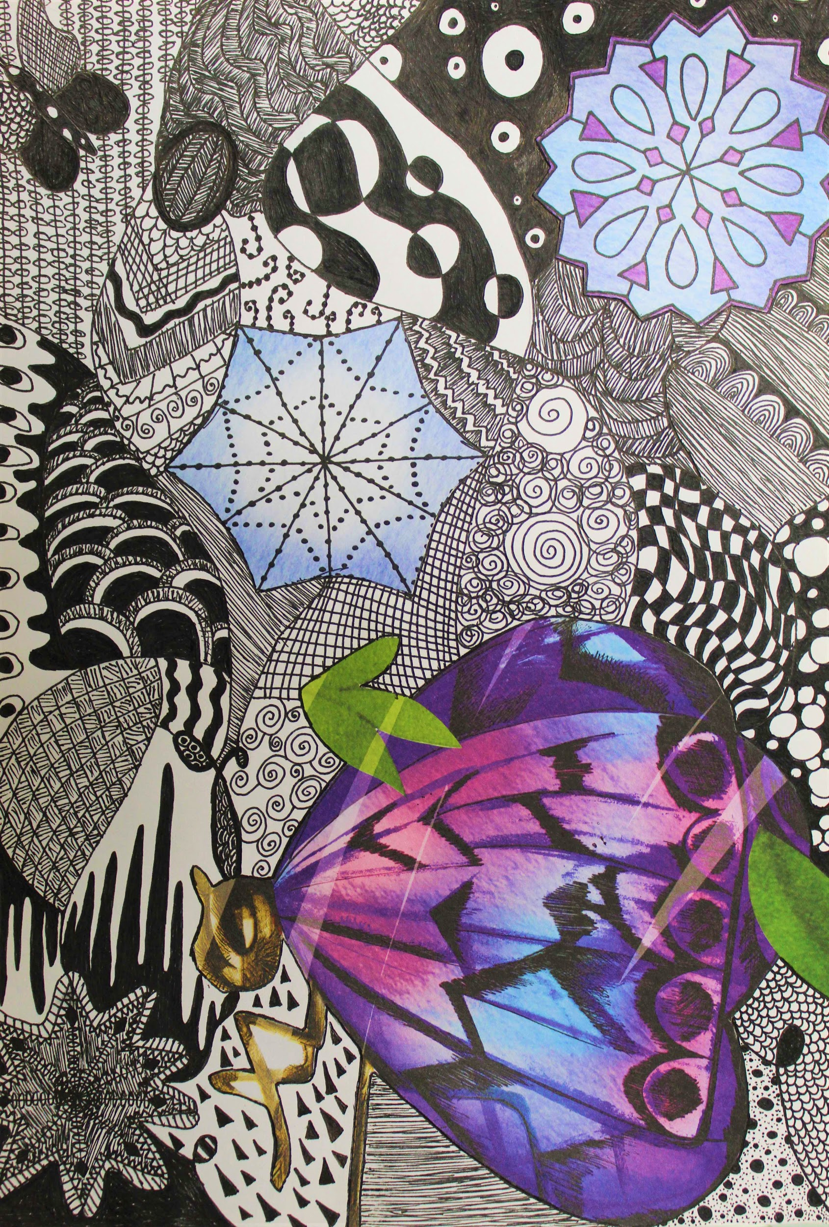
Butterfly Zentangle Collage, Drawing
Elena Elias, Grade 8
Jeannette Junior High School, Teacher Erica Campbell

###

